# Results and Discussion

## Project Outcome

### A Subtopic

### Another Subtopic

## Testing and System Evaluations

Testing on a real Android phone

* Deploy in a cloud server (complicated)
* Android Studio Simulator (failed)
* adb (success)

ip addresses (127.0.0.1 vs localhsot)

**Debug On a Real Android Phone**

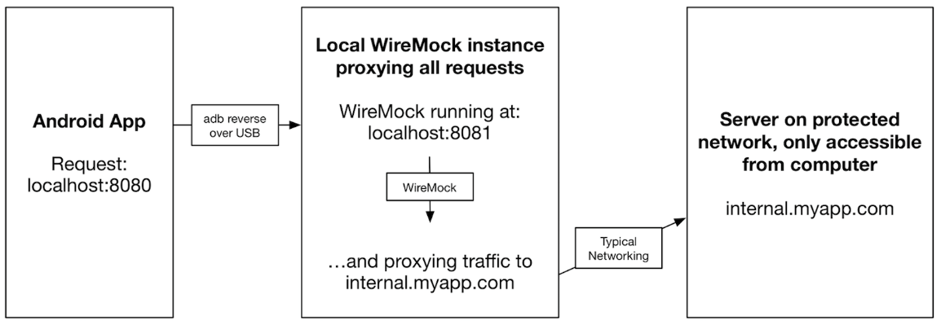Android Debug Bridge (adb) is a versatile command-line tool that enables communications with devices.

*Android Debug Bridge (ADB)*

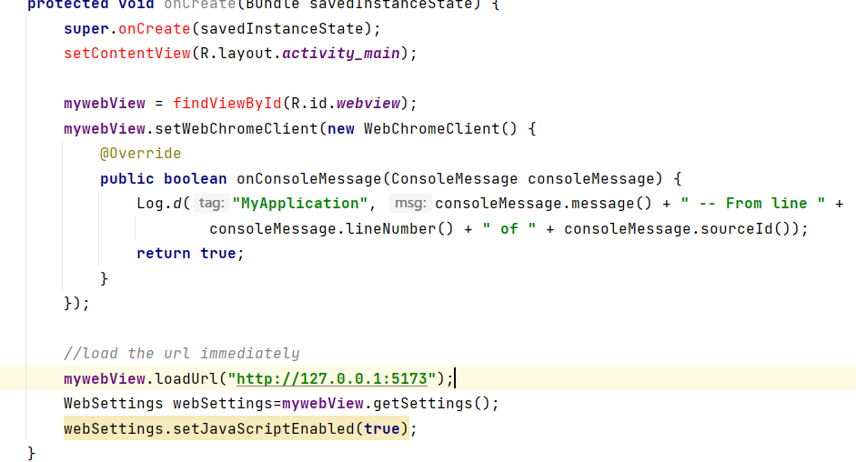

*Android Studio WebView*

By using the adb command

$ adb reverse tcp:5173 tcp:5173

$ adb reverse tcp:8080 tcp:8080

So that it allows the mobile phone to access http server with 127.0.0.1 (loopback address) to access the same host in the PC locally. In addition, the API server running on port 8080 should also be bridged to allow data communication between the mobile app and the API server.



*The vue.js accesses API server running on port 8080.*

*Screenshot (to be added)*